# Git Branches

<https://www.youtube.com/watch?v=e2IbNHi4uCI>

## 1 - Core concepts: the HEAD branch (01:51)

* 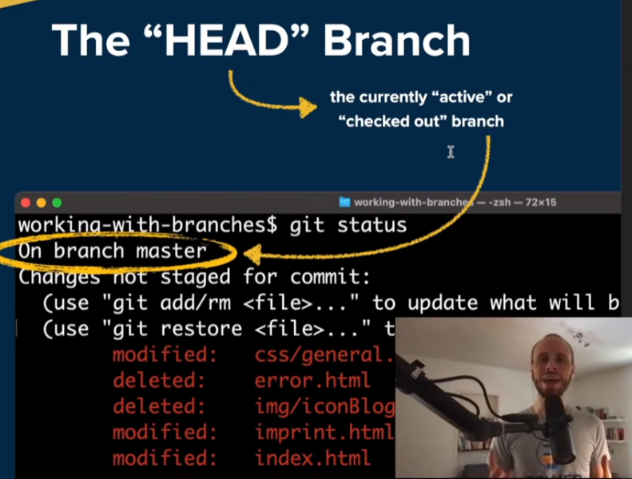

## 2 - Core concepts: local vs. remote branches (02:25)

* 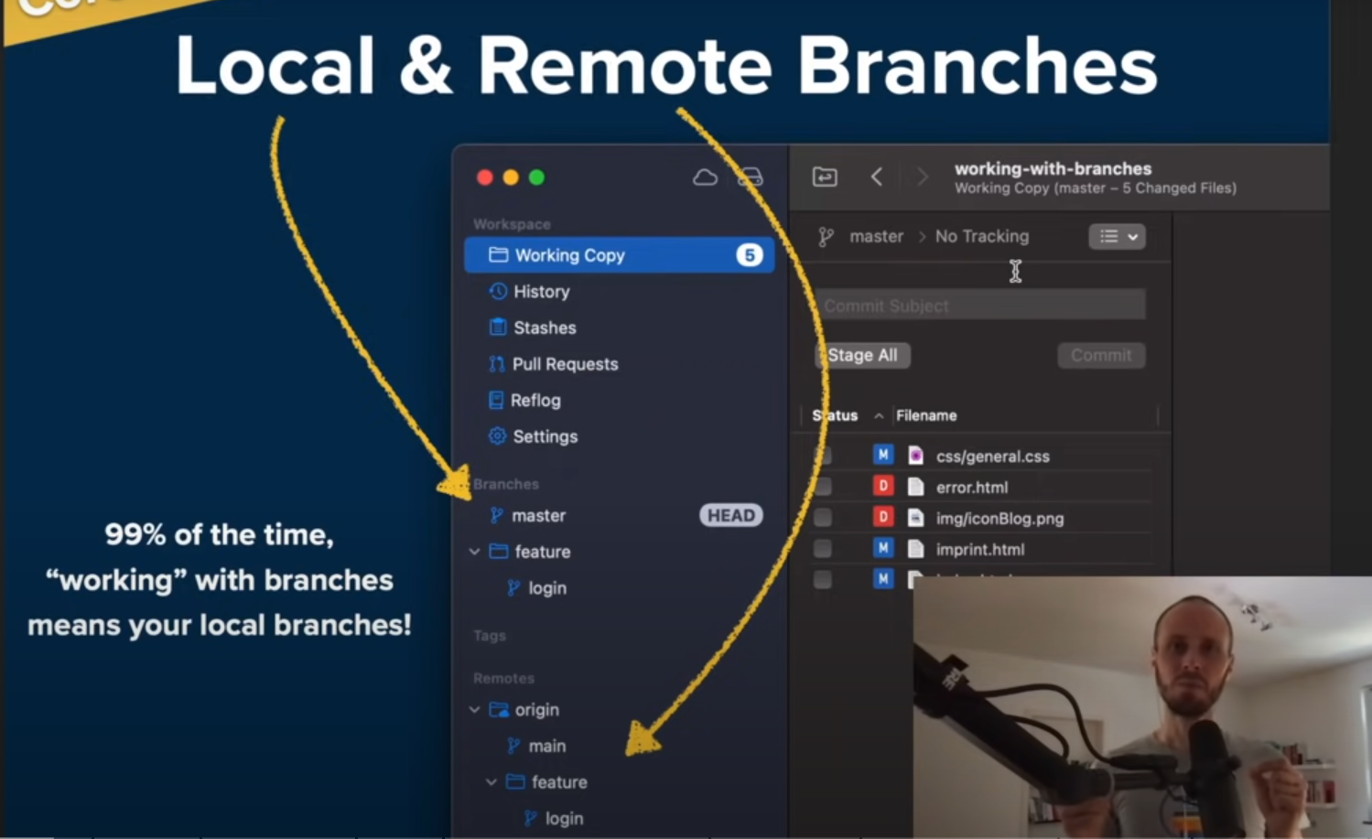

## 3 - Creating new branches (03:04)

### Based on Current Head Branch

* + 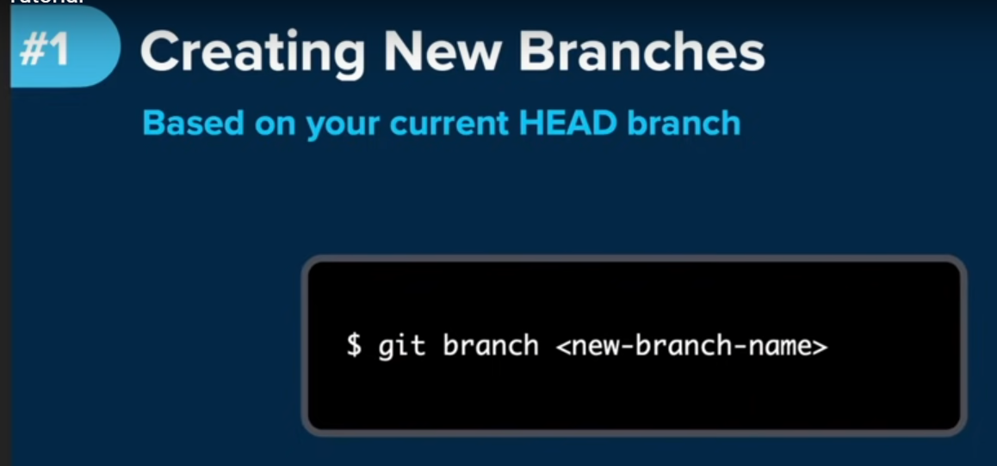
* 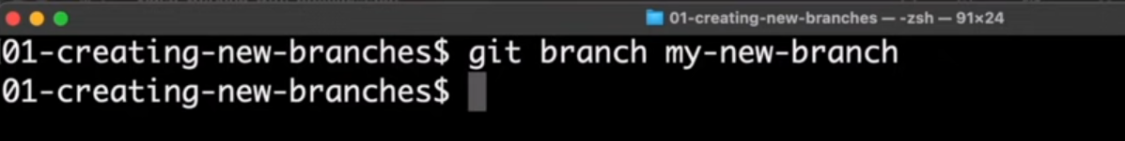
  + 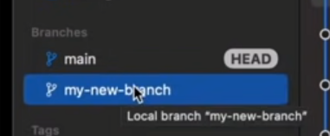 new branch created
    - NOTE THAT THIS INTERFACE is Git Tower which is 3rd party software. Maybe check github to see if you can see the branches through there.

### Based on a specific revision

* 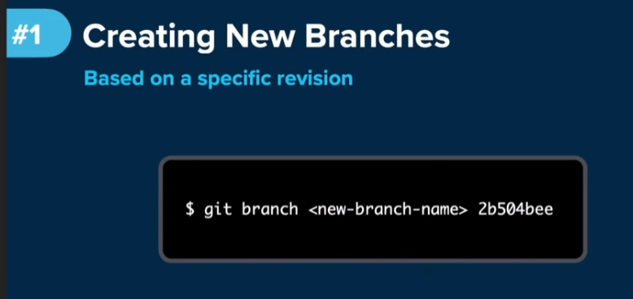
  + 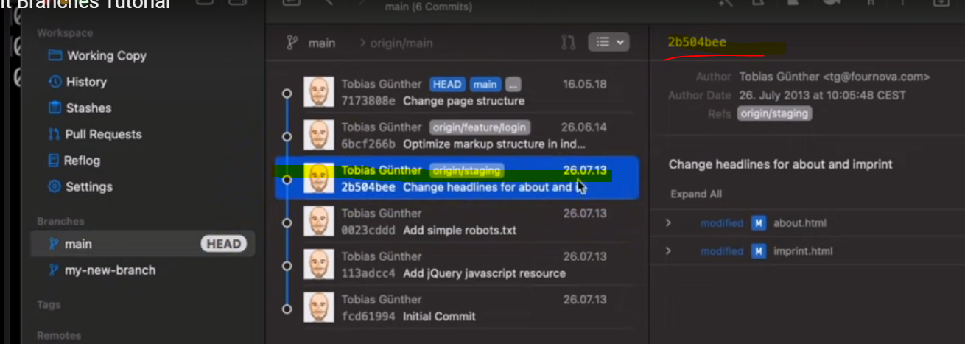
* Take that revision hash and use it when creating a new branch
  + 
  + 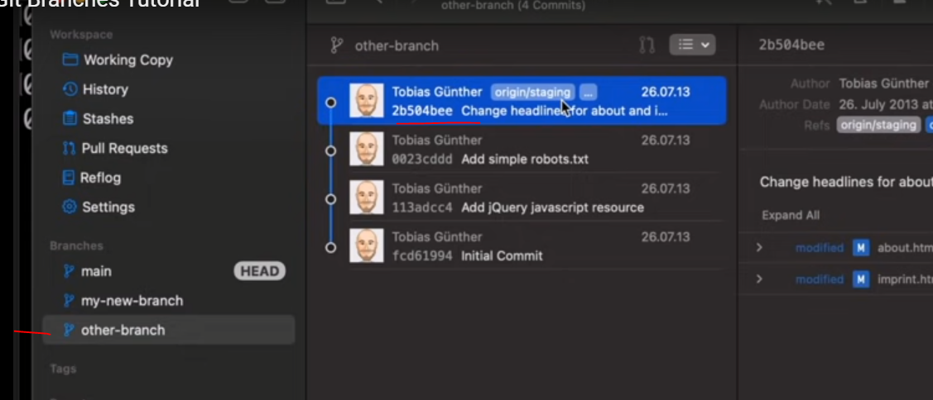

## 4 - Switching branches (05:21)

* 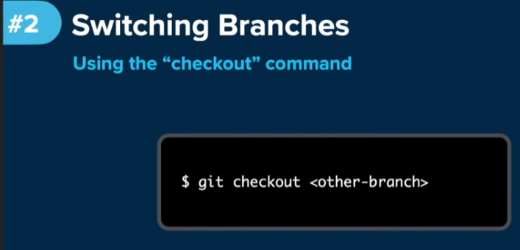
* Checking current working branch
* 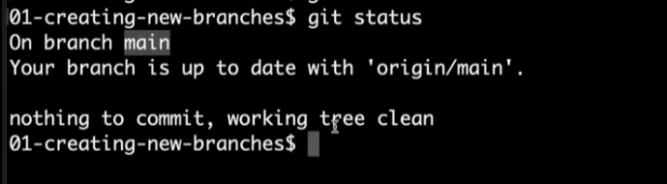

### Switch branches by using the git checkout command

* 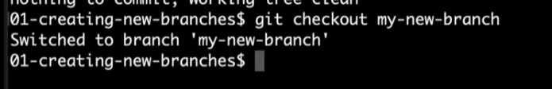

### Switch branches by using the git switch

* 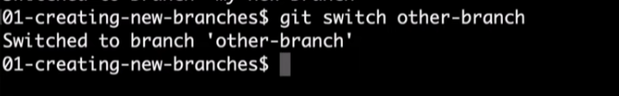
* 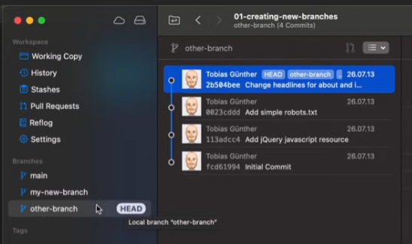
  + Shows that the HEAD is now on the “other-branch” (this is the active branch)

## 5 - Renaming branches (07:26)

* 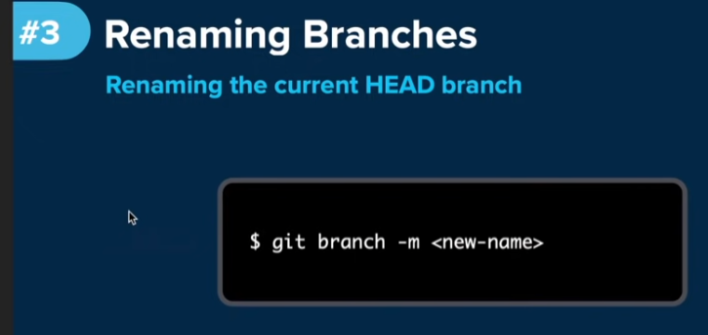

### Renaming the current HEAD branch

* 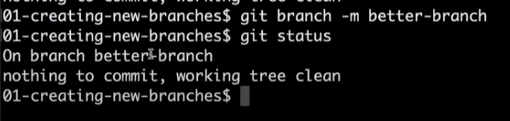

### Renaming another branch

* 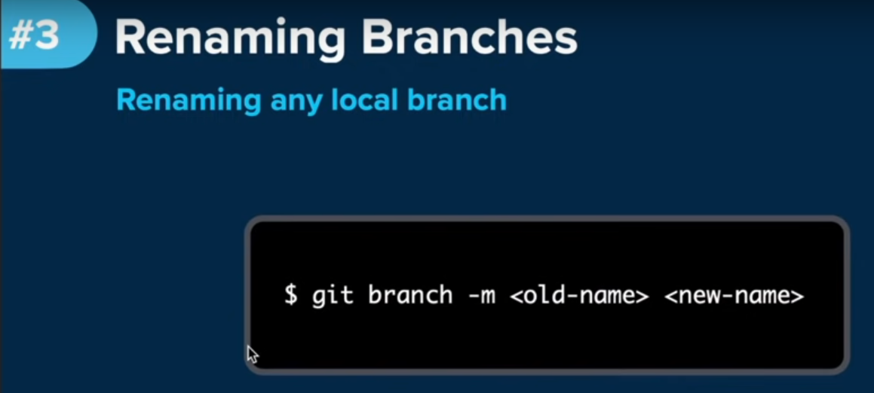
* 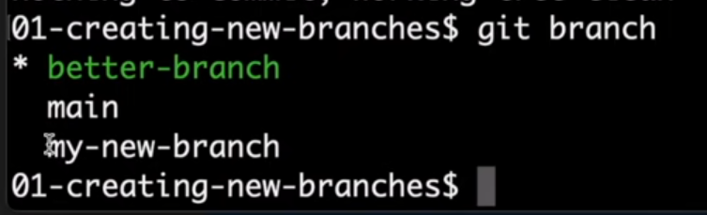
* 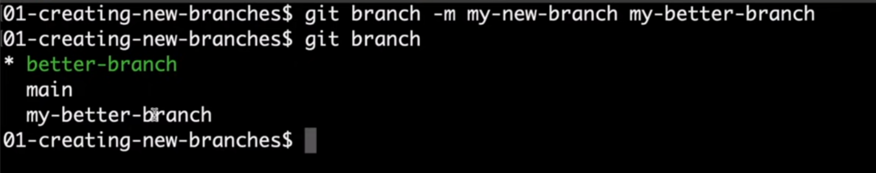
* 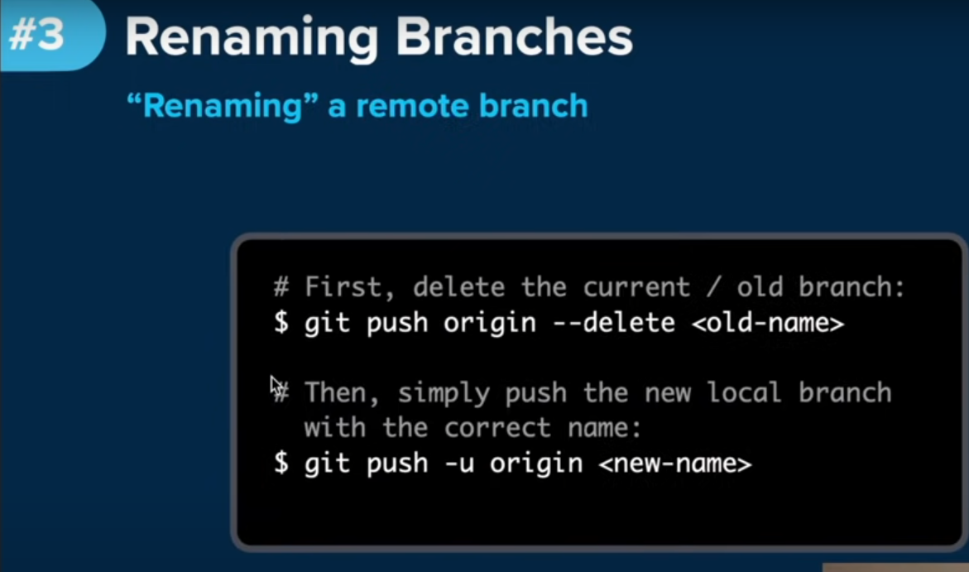

## 6 - Publishing branches (10:29)

* 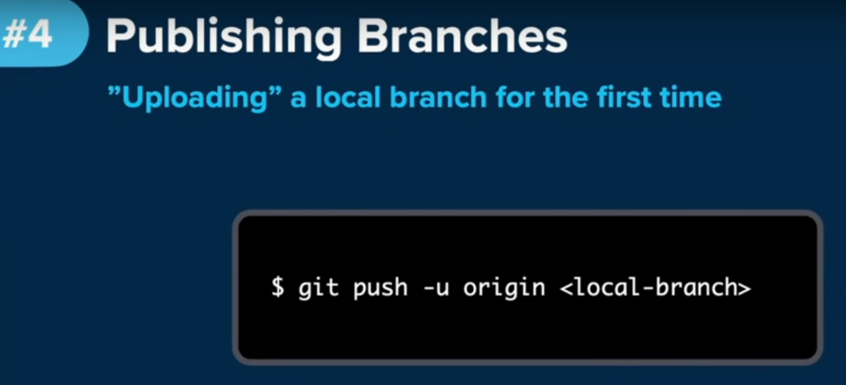
  + It is not possible to create a new branch on a remote repository. However, we can publish an existing local branch on a remote repository.
  + So we can upload what we have locally to the remote server and thereby share it with or team.
    - Local repositories reside on the computers of team members. In contrast, remote repositories are **hosted on a server that is accessible** for all team members - most likely on the internet or on a local network.
    - <https://www.git-tower.com/learn/git/ebook/en/command-line/remote-repositories/introduction#:~:text=Local%20repositories%20reside%20on%20the,or%20on%20a%20local%20network>.
* The “-u” flag tells Git to establish a tracking connection.
  + This means pushing and pulling later on will be much more easy

## 7 - Tracking branches (12:10)

* By default, local and remote branches have nothing to do with each other, they’re stored and managed as independent objects in Git.
* 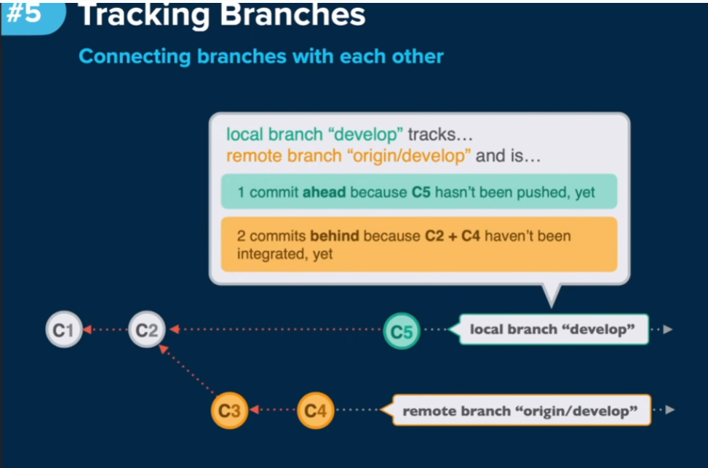
  + Here the local branch “devlop” and remote branch “origin/develop” are counterparts to one another
  + With the tracking relationship established, when you pull or push, you can push from the local branch or pull from the remote branch. Ie you can use vanilla git commmands without any further flags or parameters because the tracking relationship already knows to fill in the blank.
* 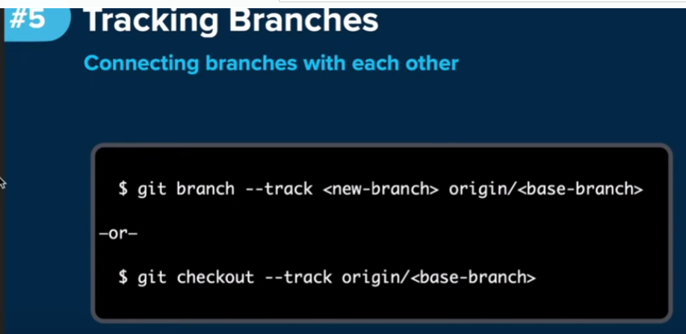

### Example – branch –track to get branches from remote to local

* 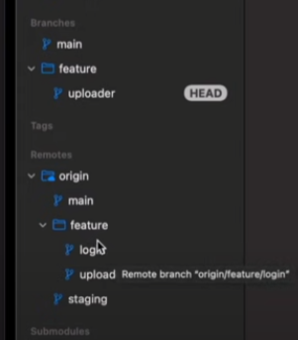
  + Local branch is several commits behind the remote branch. Local branch is missing the “login branch”
* 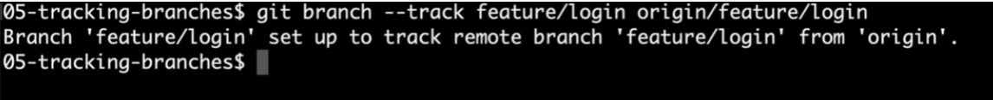
  + Track new branch “feature/login” from the “origin/feature/login”
  + So now, the local branch also has the “login branch”
  + 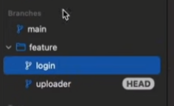

### Example2 -git checkout command

* 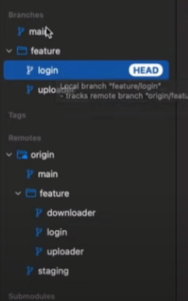 local repo is missing the downloader branch
* 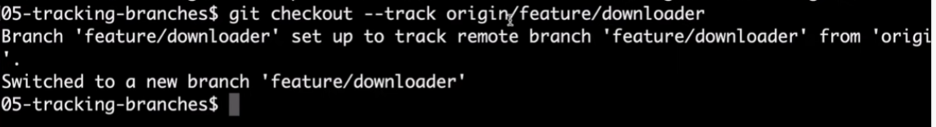
  + By not giving a local branch name, git auotmatically creates a local branch with path “feature/downloader”
  + 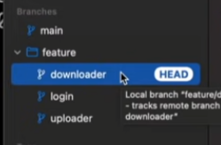

## 8 - Pulling + pushing branches (17:25)

* 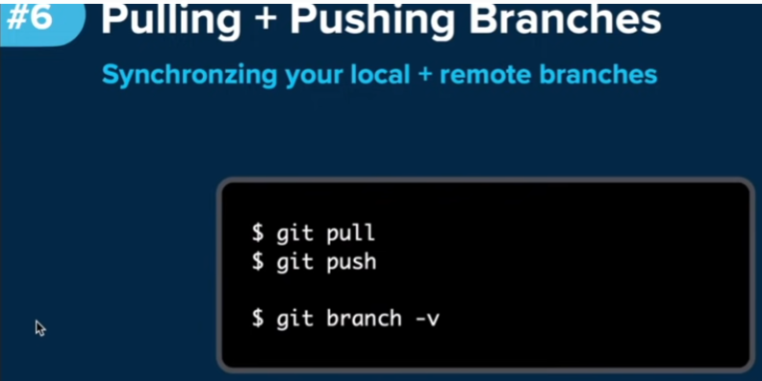
* Git by default will track connections and tell us if my local branch and the tracked remote branch diverge.
* 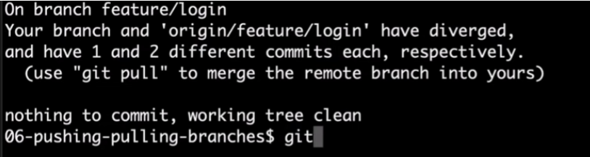
* 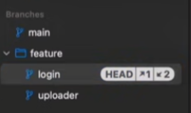
  + The ysmbols on the right mean that the remote version of “feature/login” branch doesn’t have one commit that I produced locally.
  + And the other way around, two commits are present on the the remote end (probably done by a coworker or a teammate who made some commits) and I havent pulled those down yet (haven’t downloaded them yet).

### Git branch -v

* 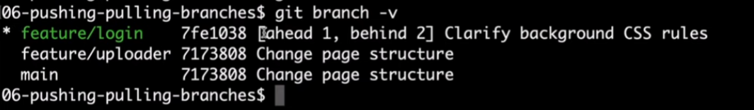
* This command gives the same information as the GIT Tower image above
  + Feature/login (local branch) is ahead of the remote by 1 commit, and the local branch is also behind by 2 commits

## 9 - Deleting branches (20:22)

* 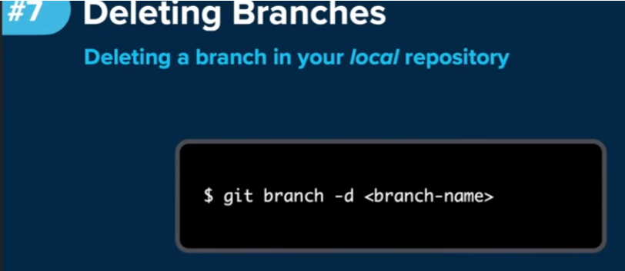
* You cannot delete the current head branch
* 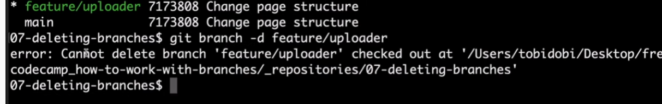
  + Get error message. You have to move to a different branch
* 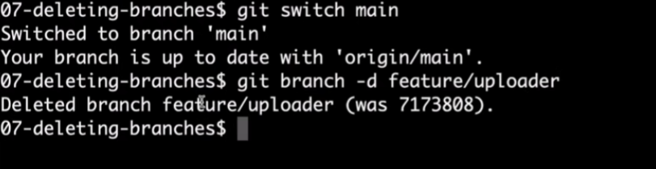
* 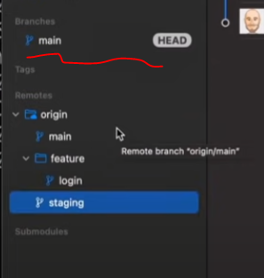 
  + So the feature/login branch is gone from the local repo

### “-f” tag to force deletion

* Can run into errors when you have made some commits to a branch but you decide to delete the branch (before pushing your commits)
* You will get a warning from GIT that the commits you made are not present on any other branch so you need to be careful to delete the branch
* To force the deletion, you must use the “-f” tag to force the deletion

### Deleting a branch saved on the remote repo

* 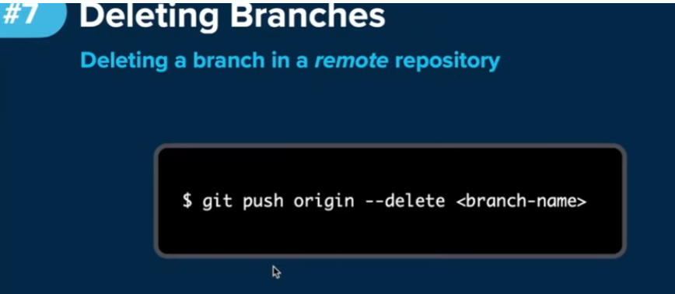
* Example – deleting the branch “feature/downloader” on the remote repo
* 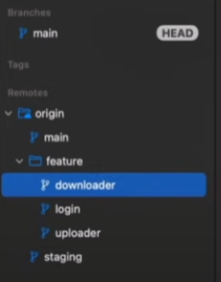
* VIDEO IS A BLACK SCREEN RIGHT HERE

## 10 - Merging branches (24:15)

* 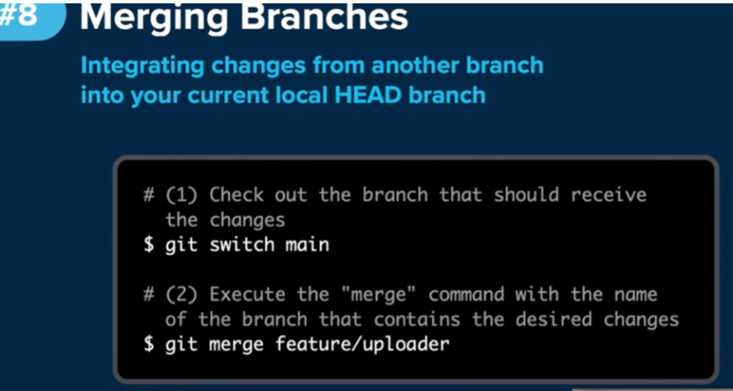
* Bringing new commits from another branch into your current local head branch
* First step is to switch into the branch that you want to have the changes come into that should receive the changes
* Second step is to execute the merge command with the name of the branch that has the desire changes

### Example

* 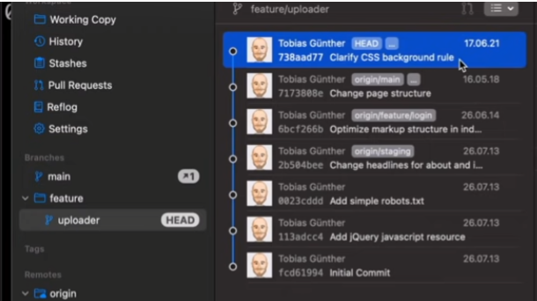
  + Main branch on local repo is ahead of the remote repo by one commit
  + Feature/uploader also has two commits (not sure where that’s shown on the Tower GUI)
* 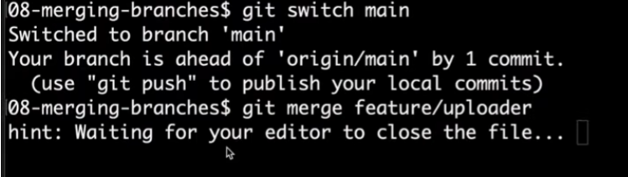
  + Switch to main and merge “main” branch with the “feature/uploader” branch which has additional commits
  + 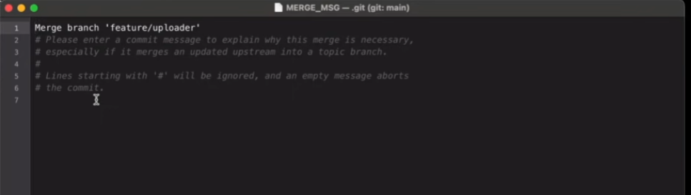
  + Instructor’s system opened up a text editor for writing a commit message
  + Because merging branches most often (not always) is a new commit.
  + 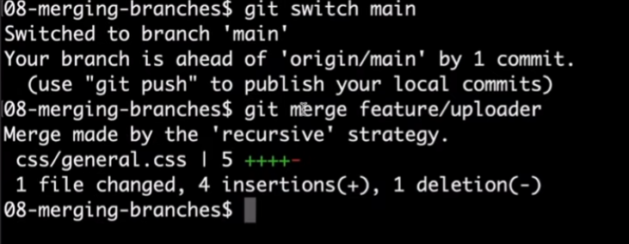
* Now on the tower GUI, you can see that the main branch on the local repo is ahead of the branch on the remote repo by three commits
* 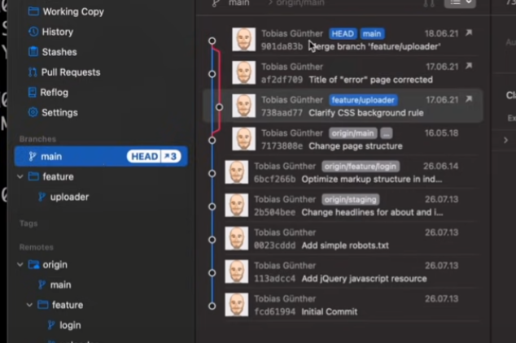
* 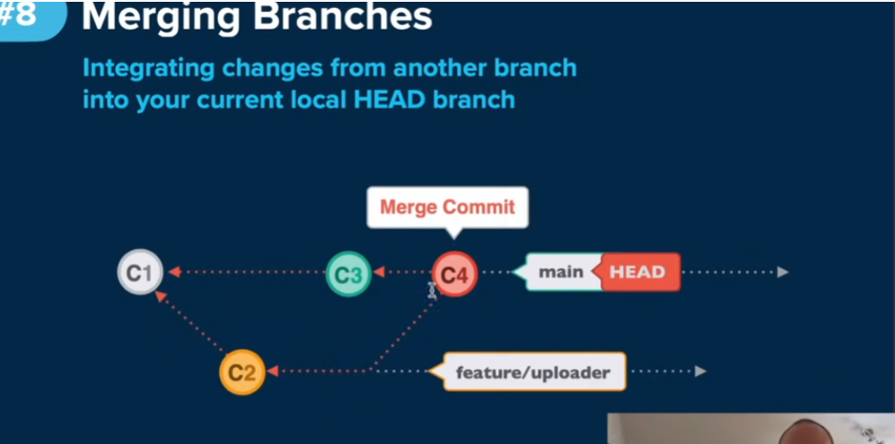

## 11 - Rebasing branches (26:52)

* 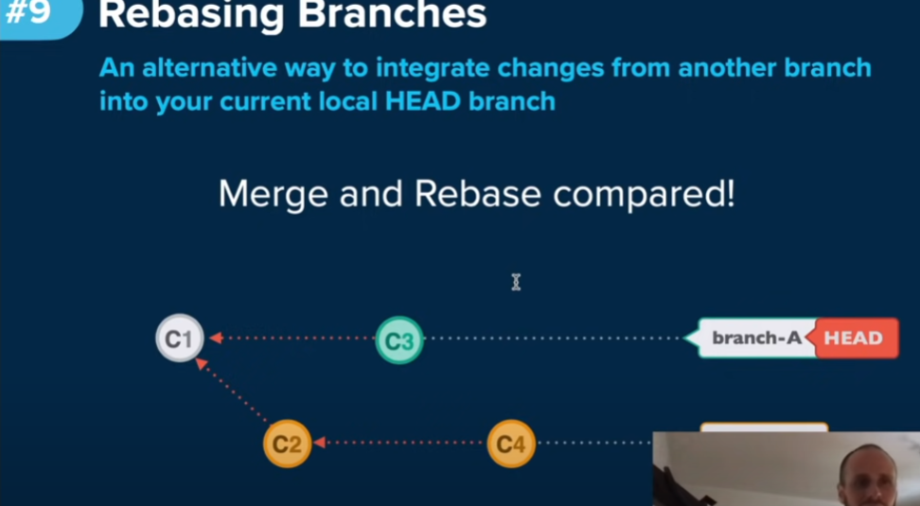
  + 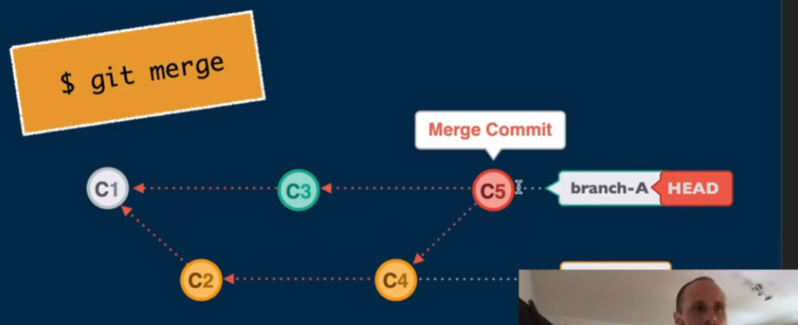
  + 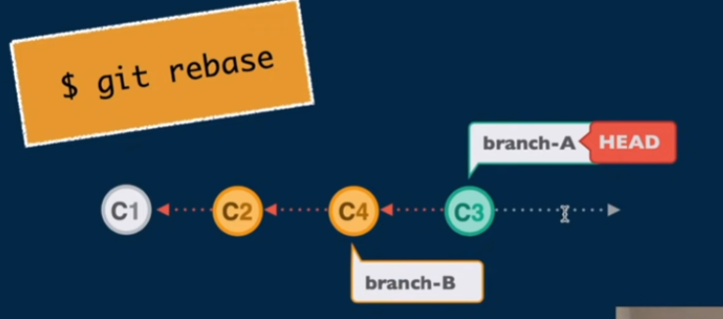
* 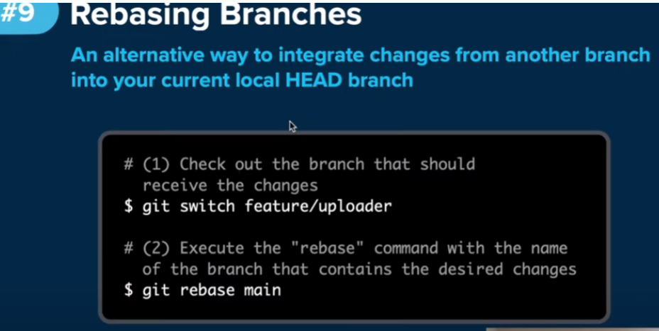
* 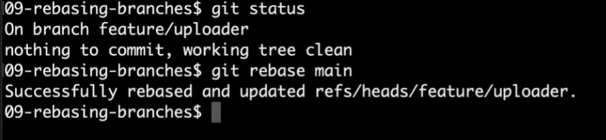

## 12 - Comparing branches (30:20)

* 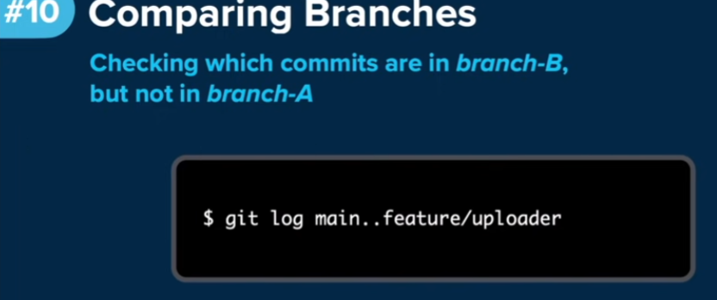
* 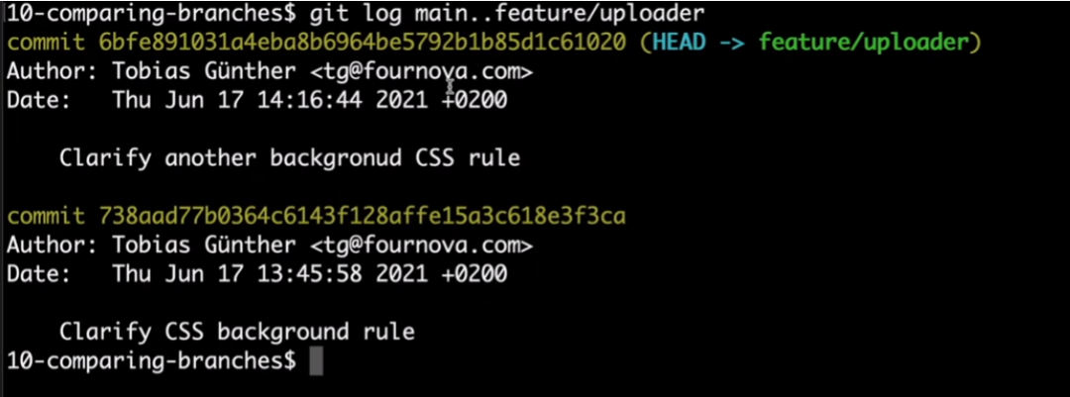
  + This shows me which commits are in our feature/uploader branch and not in the main branch

### Compare local main vs remote repo main

* 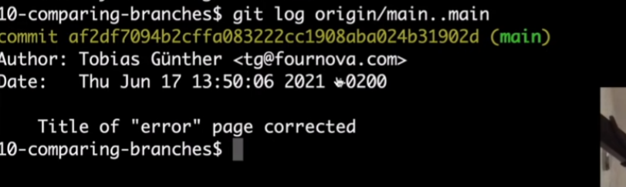
* 13 - Working with Branches Cheat Sheet: a handy resource for your daily work, free to (32:30)